Decorator Design Pattern

According GOF

**Intent**

Attach additional responsibilities to an object dynamically. Decorators provide a flexible alternative to subclassing for extending functionality.

### Motivation

Sometimes we want to add responsibilities to individual objects, not to an entire class. A graphical user interface toolkit, for example, should let you add properties like borders or behaviors like scrolling to any user interface component.

One way to add responsibilities is with inheritance. Inheriting a border from another class puts a border around every subclass instance. This is inflexible, however, because the choice of border is made statically. A client can't control how and when to decorate the component with a border.

A more flexible approach is to enclose the component in another object that adds the border. The enclosing object is called a **decorator**. The decorator conforms to the interface of the component it decorates so that its presence is transparent to the component's clients. The decorator forwards requests to the component and may perform additional actions (such as drawing a border) before or after forwarding. Transparency lets you nest decorators recursively, thereby allowing an unlimited number of added responsibilities.

### UML

The ScrollDecorator and BorderDecorator classes are subclasses of Decorator, an abstract class for visual components that decorate other visual components.

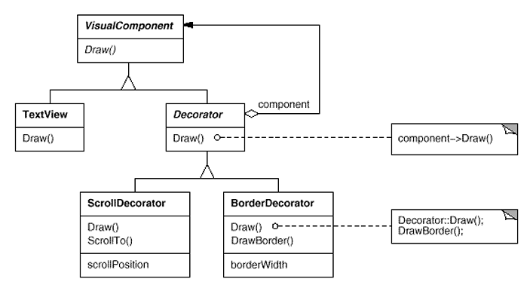

VisualComponent is the abstract class for visual objects. It defines their drawing and event handling interface. Note how the Decorator class simply forwards draw requests to its component, and how Decorator subclasses can extend this operation.

Decorator subclasses are free to add operations for specific functionality. For example, ScrollDecorator's ScrollTo operation lets other objects scroll the interface if they know there happens to be a ScrollDecorator object in the interface. The important aspect of this pattern is that it lets decorators appear anywhere a VisualComponent can. That way clients generally can't tell the difference between a decorated component and an undecorated one, and so they don't depend at all on the decoration.

### Applicability

Use Decorator

* to add responsibilities to individual objects dynamically and transparently, that is, without affecting other objects.
* for responsibilities that can be withdrawn.
* when extension by subclassing is impractical. Sometimes a large number of independent extensions are possible and would produce an explosion of subclasses to support every combination. Or a class definition may be hidden or otherwise unavailable for subclassing.

### Actual UML Diagram

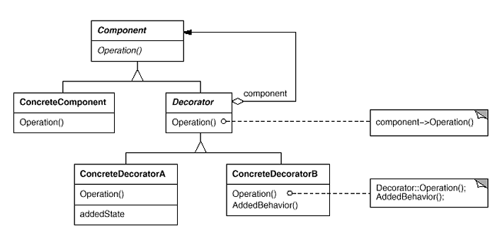

**Participants**

* **Component** (VisualComponent)
  + defines the interface for objects that can have responsibilities added to them dynamically.
* **ConcreteComponent** (TextView)
  + defines an object to which additional responsibilities can be attached.
* **Decorator**
  + maintains a reference to a Component object and defines an interface that conforms to Component's interface.
* **ConcreteDecorator** (BorderDecorator, ScrollDecorator)
  + adds responsibilities to the component.

**Collaborations**

* Decorator forwards requests to its Component object. It may optionally perform additional operations before and after forwarding the request.

**Consequences**

The Decorator pattern has at least two key benefits and two liabilities:

1. *More flexibility than static inheritance.* The Decorator pattern provides a more flexible way to add responsibilities to objects than can be had with static (multiple) inheritance. With decorators, responsibilities can be added and removed at run-time simply by attaching and detaching them. In contrast, inheritance requires creating a new class for each additional responsibility (e.g., BorderedScrollableTextView, BorderedTextView). This gives rise to many classes and increases the complexity of a system. Furthermore, providing different Decorator classes for a specific Component class lets you mix and match responsibilities.

Decorators also make it easy to add a property twice. For example, to give a TextView a double border, simply attach two BorderDecorators. Inheriting from a Border class twice is error-prone at best.

1. *Avoids feature-laden classes high up in the hierarchy.* Decorator offers a pay-as-you-go approach to adding responsibilities. Instead of trying to support all foreseeable features in a complex, customizable class, you can define a simple class and add functionality incrementally with Decorator objects. Functionality can be composed from simple pieces. As a result, an application needn't pay for features it doesn't use. It's also easy to define new kinds of Decorators independently from the classes of objects they extend, even for unforeseen extensions. Extending a complex class tends to expose details unrelated to the responsibilities you're adding.
2. *A decorator and its component aren't identical.* A decorator acts as a transparent enclosure. But from an object identity point of view, a decorated component is not identical to the component itself. Hence you shouldn't rely on object identity when you use decorators.
3. *Lots of little objects.* A design that uses Decorator often results in systems composed of lots of little objects that all look alike. The objects differ only in the way they are interconnected, not in their class or in the value of their variables. Although these systems are easy to customize by those who understand them, they can be hard to learn and debug.

### Related Patterns

**Adapter** : A decorator is different from an adapter in that a decorator only changes an object's responsibilities, not its interface; an adapter will give an object a completely new interface.

**Composite** : A decorator can be viewed as a degenerate composite with only one component. However, a decorator adds additional responsibilities—it isn't intended for object aggregation.

**Strategy** : A decorator lets you change the skin of an object; a strategy lets you change the guts. These are two alternative ways of changing an object.

# Source Code

## Type-1

**package** com.design.pattern.decorator.type1;

**public** **interface** **Shape** {

**void** draw();

}

**package** com.design.pattern.decorator.type1;

**public** **class** **Circle** **implements** Shape {

@Override

**public** **void** draw() {

System.***out***.println("Shape: Circle");

}

}

**package** com.design.pattern.decorator.type1;

**public** **class** **Rectangle** **implements** Shape {

@Override

**public** **void** draw() {

System.***out***.println("Shape: Rectangle");

}

}

**package** com.design.pattern.decorator.type1;

**public** **abstract** **class** **ShapeDecorator** **implements** Shape {

**protected** Shape decoratedShape;

**public** ShapeDecorator(Shape decoratedShape){

**this**.decoratedShape = decoratedShape;

}

**public** **void** draw(){

decoratedShape.draw();

}

}

**package** com.design.pattern.decorator.type1;

**public** **class** **RedShapeDecorator** **extends** ShapeDecorator {

**public** RedShapeDecorator(Shape decoratedShape) {

**super**(decoratedShape);

}

@Override

**public** **void** draw() {

decoratedShape.draw();

setRedBorder(decoratedShape);

}

**private** **void** setRedBorder(Shape decoratedShape){

System.***out***.println("Border Color: Red");

}

}

**package** com.design.pattern.decorator.type1;

**public** **class** **DecoratorPatternDemo** {

**public** **static** **void** main(String[] args) {

Shape circle = **new** Circle();

//Normal Circle

System.***out***.println("Normal Circle");

circle.draw();

System.***out***.println("Circle with border");

Shape redCircle = **new** RedShapeDecorator(circle);

redCircle.draw();

Shape redRectangle = **new** RedShapeDecorator(**new** Rectangle());

System.***out***.println("\nRectangle of red border");

redRectangle.draw();

}

}

## Type-2

**package** com.design.pattern.decorator.type2;

**public** **interface** **IEmail**

{

**public** String getContents();

}

**package** com.design.pattern.decorator.type2;

//concrete component

**public** **class** **Email** **implements** IEmail

{

**private** String content;

**public** Email(String content)

{

**this**.content = content;

}

@Override

**public** String getContents()

{

//general email stuff

**return** content;

}

}

**package** com.design.pattern.decorator.type2;

**public** **abstract** **class** **EmailDecorator** **implements** IEmail

{

//wrapped component

IEmail originalEmail;

@Override

**public** String getContents() {

**return** originalEmail.getContents();

}

}

**package** com.design.pattern.decorator.type2;

//concrete decorator

**public** **class** **ExternalEmailDecorator** **extends** EmailDecorator

{

**private** String content;

**public** ExternalEmailDecorator(IEmail basicEmail)

{

originalEmail = basicEmail;

}

@Override

**public** String getContents()

{

// secure original

content = addDisclaimer(originalEmail.getContents());

**return** content;

}

**private** String addDisclaimer(String message)

{

//append company disclaimer to message

**return** message + "\n Company Disclaimer";

}

}

**package** com.design.pattern.decorator.type2;

**public** **class** **EmailSender**

{

**public** **void** sendEmail(IEmail email)

{

//read the email to-address, to see if it's going outside of the company

//if so decorate it

IEmail external = **new** ExternalEmailDecorator(email);

System.***out***.println(external.getContents());

//send

}

**public** **static** **void** main(String[] args) {

EmailSender mail = **new** EmailSender();

IEmail email1 = **new** Email("ssadasds");

mail.sendEmail(email1);

}

}

## Type – 3

**package** com.design.pattern.decorator.type3;

**public** **interface** **Car** {

**public** **void** assemble();

}

**package** com.design.pattern.decorator.type3;

**public** **class** **BasicCar** **implements** Car {

@Override

**public** **void** assemble() {

System.***out***.print("Basic Car.");

}

}

**package** com.design.pattern.decorator.type3;

**public** **abstract** **class** **CarDecorator** **implements** Car {

**protected** Car car;

**public** CarDecorator(Car c){

**this**.car=c;

}

@Override

**public** **void** assemble() {

**this**.car.assemble();

}

}

**package** com.design.pattern.decorator.type3;

**public** **class** **LuxuryCar** **extends** CarDecorator {

**public** LuxuryCar(Car c) {

**super**(c);

}

@Override

**public** **void** assemble(){

car.assemble();

System.***out***.print(" Adding features of Luxury Car.");

}

}

**package** com.design.pattern.decorator.type3;

**public** **class** **SportsCar** **extends** CarDecorator {

**public** SportsCar(Car c) {

**super**(c);

}

@Override

**public** **void** assemble(){

car.assemble();

System.***out***.print(" Adding features of Sports Car.");

}

}

**package** com.design.pattern.decorator.type3;

**public** **class** **DecoratorPatternTest** {

**public** **static** **void** main(String[] args) {

Car sportsCar = **new** SportsCar(**new** BasicCar());

sportsCar.assemble();

System.***out***.println("\n*****");

Car sportsLuxuryCar = **new** SportsCar(**new** LuxuryCar(**new** BasicCar()));

sportsLuxuryCar.assemble();

}

}

# Type – 4 – From Wikipedia

**package** com.design.pattern.decorator.type4;

**public** **interface** **Window** {

**public** **void** draw(); // Draws the Window

**public** String getDescription(); // Returns a description of the Window

}

**package** com.design.pattern.decorator.type4;

**class** **SimpleWindow** **implements** Window {

**public** **void** draw() {

// Draw window

}

**public** String getDescription() {

**return** "simple window";

}

}

**package** com.design.pattern.decorator.type4;

**class** **HorizontalScrollBarDecorator** **extends** WindowDecorator {

**public** HorizontalScrollBarDecorator (Window windowToBeDecorated) {

**super**(windowToBeDecorated);

}

@Override

**public** **void** draw() {

**super**.draw();

drawHorizontalScrollBar();

}

**private** **void** drawHorizontalScrollBar() {

// Draw the horizontal scrollbar

}

@Override

**public** String getDescription() {

**return** **super**.getDescription() + ", including horizontal scrollbars";

}

}

**package** com.design.pattern.decorator.type4;

**class** **VerticalScrollBarDecorator** **extends** WindowDecorator {

**public** VerticalScrollBarDecorator (Window windowToBeDecorated) {

**super**(windowToBeDecorated);

}

@Override

**public** **void** draw() {

**super**.draw();

drawVerticalScrollBar();

}

**private** **void** drawVerticalScrollBar() {

// Draw the vertical scrollbar

}

@Override

**public** String getDescription() {

**return** **super**.getDescription() + ", including vertical scrollbars";

}

}

**package** com.design.pattern.decorator.type4;

**abstract** **class** **WindowDecorator** **implements** Window {

**protected** Window windowToBeDecorated; // the Window being decorated

**public** WindowDecorator (Window windowToBeDecorated) {

**this**.windowToBeDecorated = windowToBeDecorated;

}

**public** **void** draw() {

windowToBeDecorated.draw(); //Delegation

}

**public** String getDescription() {

**return** windowToBeDecorated.getDescription(); //Delegation

}

}

**package** com.design.pattern.decorator.type4;

**public** **class** **DecoratedWindowTest** {

**public** **static** **void** main(String[] args) {

// Create a decorated Window with horizontal and vertical scrollbars

Window decoratedWindow = **new** HorizontalScrollBarDecorator (

**new** VerticalScrollBarDecorator (**new** SimpleWindow()));

// Print the Window's description

System.***out***.println(decoratedWindow.getDescription());

}

}

Similarly you can provide the following example

* + 1. Assault rifle with telescope and night vision
    2. Order management with premium order with gift wrap.
    3. Generation of monthly report and yearly report.
    4. Credit Card with micro chip.
    5. Car with bullet proof.